WEEK 3 Spring Core Maven Spring Data Jpa

Question :

**Exercise 1: Configuring a Basic Spring Application**

**Scenario:**

Your company is developing a web application for managing a library. You need to use the Spring Framework to handle the backend operations.

**Steps:**

1. **Set Up a Spring Project:**
   * Create a Maven project named **LibraryManagement**.
   * Add Spring Core dependencies in the **pom.xml** file.
2. **Configure the Application Context:**
   * Create an XML configuration file named **applicationContext.xml** in the **src/main/resources** directory.
   * Define beans for **BookService** and **BookRepository** in the XML file.
3. **Define Service and Repository Classes:**
   * Create a package **com.library.service** and add a class **BookService**.
   * Create a package **com.library.repository** and add a class **BookRepository**.
4. **Run the Application:**
   * Create a main class to load the Spring context and test the configuration.

Answer

Code

**BookRepository.java**

package com.library.repository;

public class BookRepository {

    public void displayBooks() {

        System.out.println("Fetching all books from the repository...");

    }

}

**BookService.java**

package com.library.service;

import com.library.repository.BookRepository;

public class BookService {

    private BookRepository bookRepository;

    public void setBookRepository(BookRepository bookRepository) {

        this.bookRepository = bookRepository;

    }

    public void listBooks() {

        bookRepository.displayBooks();

    }

}

**LibraryApp.java**

package com.library;

import com.library.service.BookService;

import org.springframework.context.ApplicationContext;

import org.springframework.context.support.ClassPathXmlApplicationContext;

public class LibraryApp {

    public static void main(String[] args) {

        ApplicationContext context = new ClassPathXmlApplicationContext("applicationContext.xml");

        BookService bookService = context.getBean("bookService", BookService.class);

        bookService.listBooks();

    }

}

**.xml**

**<?xml version="1.0" encoding="UTF-8"?>**

**<beans xmlns="http://www.springframework.org/schema/beans"**

**xmlns:xsi="http://www.w3.org/2001/XMLSchema-instance"**

**xsi:schemaLocation="http://www.springframework.org/schema/beans**

**https://www.springframework.org/schema/beans/spring-beans.xsd">**

**<bean id="bookRepository" class="com.library.repository.BookRepository"/>**

**<bean id="bookService" class="com.library.service.BookService">**

**<property name="bookRepository" ref="bookRepository"/>**

**</bean>**

**</beans>**

**Output**

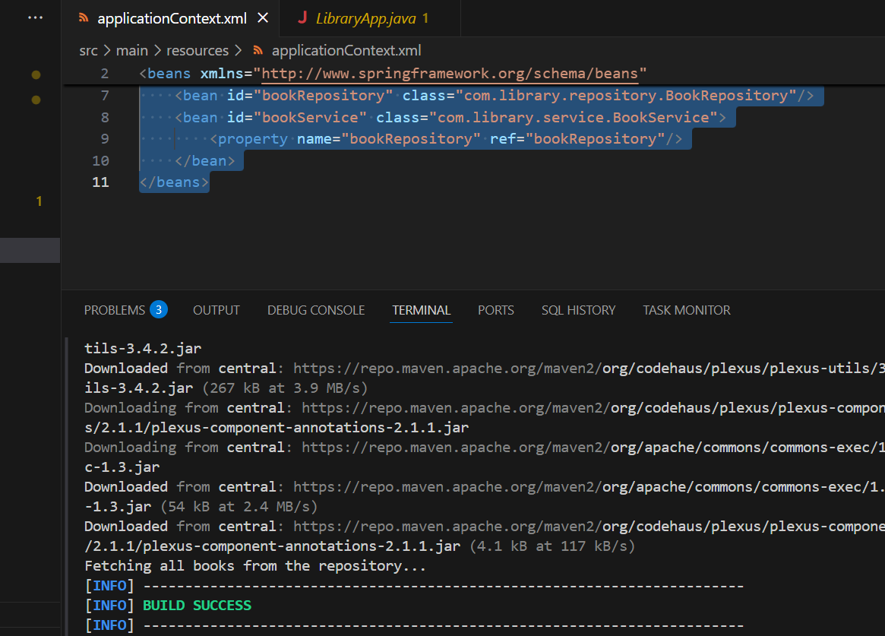

**Question**

**Exercise 2: Implementing Dependency Injection**

**Scenario:**

**In the library management application, you need to manage the dependencies between the BookService and BookRepository classes using Spring's IoC and DI.**

**Steps:**

1. **Modify the XML Configuration:**
   * **Update applicationContext.xml to wire BookRepository into BookService.**
2. **Update the BookService Class:**
   * **Ensure that BookService class has a setter method for BookRepository.**
3. **Test the Configuration:**

**Run the LibraryManagementApplication main class to verify the dependency injection**

**Answer**

**Code :**

.xml

<?xml version="1.0" encoding="UTF-8"?>

<beans xmlns="http://www.springframework.org/schema/beans"

       xmlns:xsi="http://www.w3.org/2001/XMLSchema-instance"

       xsi:schemaLocation="http://www.springframework.org/schema/beans

<https://www.springframework.org/schema/beans/spring-beans.xsd>">

    <bean id="bookRepository" class="com.library.repository.BookRepository"/>

    <bean id="bookService" class="com.library.service.BookService">

        <property name="bookRepository" ref="bookRepository"/>

    </bean>

</beans>

**BookService.java**

package com.library.service;

import com.library.repository.BookRepository;

public class BookService {

    private BookRepository bookRepository;

    public void setBookRepository(BookRepository bookRepository) {

        this.bookRepository = bookRepository;

    }

    public void listBooks() {

        bookRepository.displayBooks();

    }

}

**Output:**

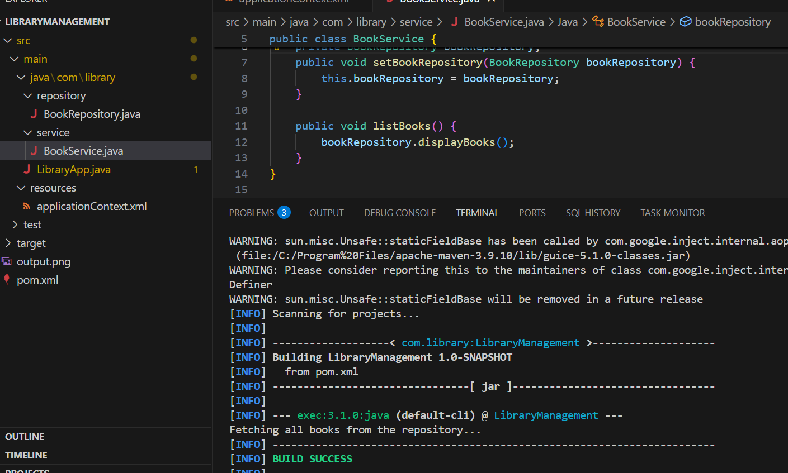

**Question**

**Exercise 4: Creating and Configuring a Maven Project**

**Scenario:**

**You need to set up a new Maven project for the library management application and add Spring dependencies.**

**Steps:**

1. **Create a New Maven Project:**
   * **Create a new Maven project named LibraryManagement.**
2. **Add Spring Dependencies in pom.xml:**
   * **Include dependencies for Spring Context, Spring AOP, and Spring WebMVC.**
3. **Configure Maven Plugins:**
   * **Configure the Maven Compiler Plugin for Java version 1.8 in the pom.xml file.**

**Answer**

**Code**

**pom.xml**

<project xmlns="http://maven.apache.org/POM/4.0.0"

         xmlns:xsi="http://www.w3.org/2001/XMLSchema-instance"

         xsi:schemaLocation="http://maven.apache.org/POM/4.0.0

                             http://maven.apache.org/xsd/maven-4.0.0.xsd">

    <modelVersion>4.0.0</modelVersion>

    <groupId>com.library</groupId>

    <artifactId>LibraryManagement</artifactId>

    <version>1.0-SNAPSHOT</version>

    <dependencies>

        <dependency>

            <groupId>org.springframework</groupId>

            <artifactId>spring-context</artifactId>

            <version>5.3.36</version>

        </dependency>

        <dependency>

            <groupId>org.springframework</groupId>

            <artifactId>spring-aop</artifactId>

            <version>5.3.36</version>

        </dependency>

        <dependency>

            <groupId>org.springframework</groupId>

            <artifactId>spring-webmvc</artifactId>

            <version>5.3.36</version>

        </dependency>

    </dependencies>

    <build>

        <plugins>

            <plugin>

                <groupId>org.apache.maven.plugins</groupId>

                <artifactId>maven-compiler-plugin</artifactId>

                <version>3.8.1</version>

                <configuration>

                    <source>1.8</source>

                    <target>1.8</target>

                </configuration>

            </plugin>

        </plugins>

    </build>

**</project>**

**Output:**

